YOUR HEALTH NEWS  THE RIDGEWAY SURGERY AND  RIDGEWAY SURGERY PATIENT PARTICIPATION GROUP NEWSLETTER  Autumn Edition 2024 | 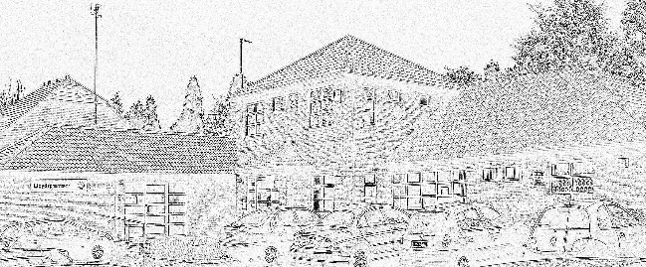

*** Welcome to the fifth edition of The Ridgeway Surgery Newsletter ***
(If you need this Newsletter in LARGER PRINT or an ALTERNATIVE LANGUAGE, please advise Reception).
A copy of this Newsletter will appear on the website : www.ridgewaysurgery.co.uk.
Please feel free to take a copy of this Newsletter home with you. There are feedback forms on the Website and in Reception. Do keep Reception updated with any changes to your contact details.

AUTUMN VACCINATIONS
RSV (Respiratory Syncytial Virus)– RSV vaccinations are currently being offered at the surgery to patients aged 75-79 years and pregnant ladies at 28 weeks gestation. RSV has not been very well publicised nationally unfortunately and therefore uptake has been slow. RSV shows flu-like symptoms and causes many hospitalisations and some fatalities each year and we highly encourage patients to have the vaccination to protect themselves.
The programme is ongoing. However to help prevent pressure on secondary care this year, we were asked to vaccinate patients in September as much as possible. Relevant patients have been contacted. If patients still would like an RSV vaccination please please ring the surgery to book in.
RSV Eligibility: if a patient is 79 and is turning 80 between 1.9.24 and 1.9.25 they are eligible for the first year of the vaccination programme, including after their 80th birthday. If they are 80 before 1.9.24 they are not eligible.
Flu and Covid – this year flu and covid have been delayed until 3rd October onwards (except for children and pregnant ladies who can have it now). This is because the government are concerned that the vaccine losses its efficacy before the end of winter if given in September. We have two Saturday clinics on 5th and 19th October and will be holding clinics each Thursday as well. Patients are being contacted to book in, or can just ring the surgery if they are aged 65+ or in an eligible risk category.

ONLINE CONSULTATIONS

There is a huge push in the NHS for general practice to become more digital. We are expected to offer patients equal opportunity to contact us face to face, via telephone or online. Patients can put a medical or admin request in online via our website, this will be reviewed and responded to within 48 hours. However urgent medical queries should not be placed via this method. These are called Online Consultations. We have this facility open all through core hours. If you launch our website there is a button to contact us online for non-urgent medical requests or admin issues. We also now send a link for sick note requests and HRT requests, once the patient completes the form via the link it is also reviewed and the sick note/HRT issued if there are no other queries.

COMMENTS FROM PATIENTS
Though our Surgery Surveys have resulted in very pleasing responses, there are occasionally issues Patients raise. Last month one was regarding not receiving blood test results. The Surgery response was “Blood test results are transferred to us from Russell’s Hall Hospital Lab, sometimes there may be a delay with our system. Please allow 7 working days, then contact the surgery for your results. If needed we can chase your results from the lab”.

FREE MOBILE DATA FOR THOSE IN NEED
The Good Things Foundation offer free mobile data for those in need. www.goodthingsfoundation.org/westmids for more information.
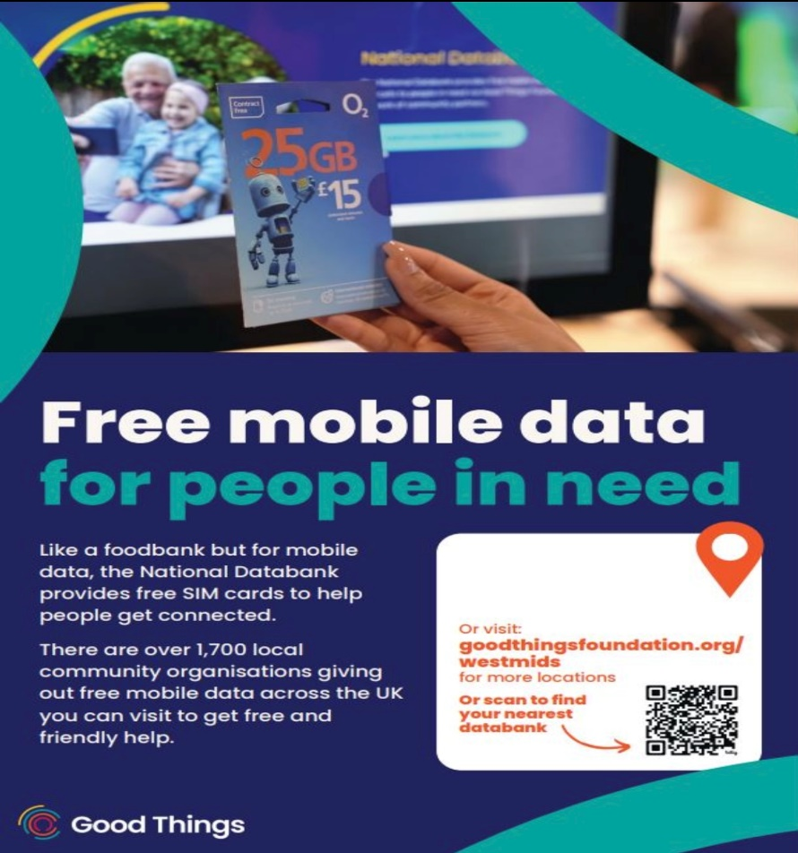
POSITIVE PEOPLE AND THEIR SERVICES

Stuart Bates ICB (Integrated Care Board) engages with individuals, community groups, people of influence, and stakeholders across the Dudley Borough. To listen to their views, insights, good practices, and any frustrations they may have on the health service and act on the feedback he receives and helps to influence decisions made at the NHS, we also work closely with our partners across the healthcare system. He often finds that communities facing health inequalities are keen to speak to us about their experiences, to raise awareness of what is working well and what could be improved. To book a community conversation please email stuart.bates4@nhs.net
Pippa Boulton (also ICB) checks how patient data is used to plan health care across the local area and how patient data is protected from outside agencies.
Queens Cross Network (Manager Paul Astley) is a drop-in Disability Hub in Wellington Road Dudley which offers different services such as a vision support service, deaf support service, enabling community support to help people live independently in their own home and provides activities such as yoga and dance. Tel: 01384 813460.

