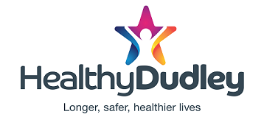

**Free monthly health and wellbeing ebulletin**

Sign up to the monthly e-bulletin from Dudley Public Health and Wellbeing. Receive updates on local health information and advice on all life stages, from pregnancy and babies to healthy ageing. Find out about free local exercise opportunities, local mental health support and much more. To receive the bulletin go to <https://public.govdelivery.com/accounts/UKDUDLEYMBC/signup/26294>

Or scan this QR code

Plus, to follow the latest health and wellbeing news, sign up to the Healthy Dudley Facebook page <https://www.facebook.com/HealthyDudley>